**Lab Report: 209L – 01 Ngyuen**

**Gene Drumheller**

**Experiment 2**

**Frequency Response of First Order Circuits**

**Objectives:** To create an RC circuit, measure and calculate the responses given, and learn how the frequency response of such circuits operates.

**Equipment’s Used:**

* Oscilloscope
* AC Voltage Generator
* Multimeter
* Capacitor-Inductor Meter
* Clip leads
* BNC Cables
* Resistor (1kΩ)
* Capacitor (0.1µF)

**Prelab:**

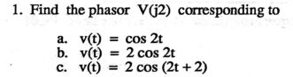

1. V(t) = ∠0°
2. V(t) = 2∠0°
3. V(t) = 2∠114.6°

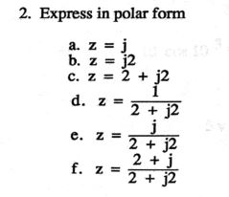

1. Z = 2e^j90°
2. Z = 2e^j45°
3. Z = 2√2e^j45°
4. Z = 0.354e^j-45°
5. Z = 0.354e^j45°
6. Z = 0.791e^j-18.48°

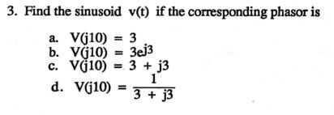

1. V(j10) = 3 = 3cos(10t)V
2. V(j10) = -2.97 +j0.43 = 3∠171.9° = 3cos(10t + 171.9°)
3. V(j10) = 3+j3 = 4.242∠45° = 4.242cos(10t +45°)
4. V(j10) = 0.166 – j0.166 = 0.235∠-45° = 0.235cos(10t - 45°)
5. V(j10) = 0.166 + j0.166 = 0.235∠45° = 0.235cos(10t + 45°)

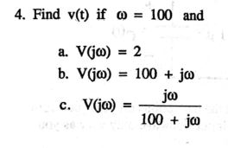

1. V(j100) = 2 = 2cos(100t)V
2. V(j100) = 100 + j 100 = 141.42cos(100t + 45°)V
3. V(j100) = 0.5 + j0.5 = 0.707cos(100t + 45°)V

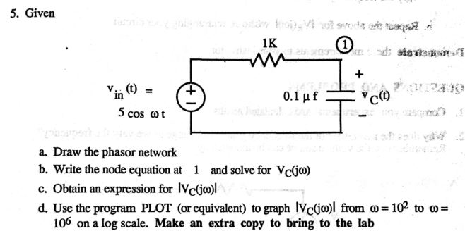

$$R→R, C→ \frac{1}{jwC}$$

$$\frac{Vc-5}{1000}+\frac{Vc}{\left(10x{10}^{6}\right)/jw}=0Vc=\frac{5000}{10000+jw}$$

$$10000Vc-5000+Vcjw=0$$

1. w = 10^2, Vc = 0.49cos((10^2) – 0.57°)V
2. w = 10^3, Vc = 0.49cos((10^3) – 5.7°)V
3. w = 10^4, Vc = 0.35cos((10^4) – 45°)V
4. w = 10^5, Vc = 0.049cos((10^5) – 84.28°)V
5. w = 10^6, Vc = 0.0049cos((10^6) – 89°)V

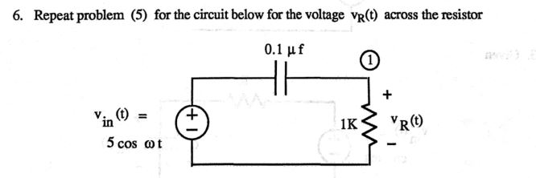

$$R→R, C→ \frac{1}{jwc}$$

$$\frac{Vr-5}{-j\left(10x{10}^{6}\right)/w}+\frac{Vr}{1000}=0$$

$$Vr=\frac{5jw}{\left(10000+jw\right)}$$

1. w = 10^2, Vc = 0.05cos((10^2) +89.42°)V
2. w = 10^3, Vc = 0.49cos((10^3) +84.28°)V
3. w = 10^4, Vc = 3.535cos((10^4) + 45°)V
4. w = 10^5, Vc = 4.98cos((10^5) + 5.71°)V
5. w = 10^6, Vc = 4.99cos((10^6) + 0.57°)V

**Lab Procedure:**

Part 1) Measure your resistor and capacitor values:

Measured resistor value = 0.9953kΩ

Nominal resistor value = 1.0kΩ

%difference = $\frac{0.9953-1}{1} x 100 \%= -0.47\%$

Measured capacitor value = 0.097µF

Nominal capacitor value = 0.1µF

%difference = $\frac{0.097-0.1}{0.1} x 100 \%= -0.03\%$

Table 1

|  |  |  |  |
| --- | --- | --- | --- |
|  | Measured | Nominal | %difference |
| Resistor | 0.9953kΩ | 1.0kΩ | -0.47% |
| Capacitor | 0.097µF | 0.1µF | -0.03% |

Part2)

Circuit 1:

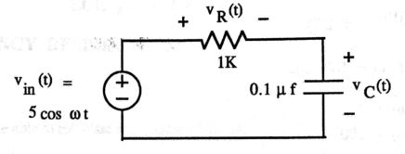

Given: Input voltage will always remain Vp = 5V or Vpp = 10V in this lab.

$$Angular Frequencies W used \left(\frac{rad}{seconds}\right)={10}^{2}, {10}^{3}, {10}^{4}, {10}^{5},{10}^{6}$$

$$Frequency used=\left(\frac{w}{2π}\right)=15.9Hz, 159Hz, 1590Hz, 15.9kHz, 159kHz$$

$$Additionally, W_{3dB} where Vp=3.5V, has a frequency of 1623Hz (calculation provided later)$$

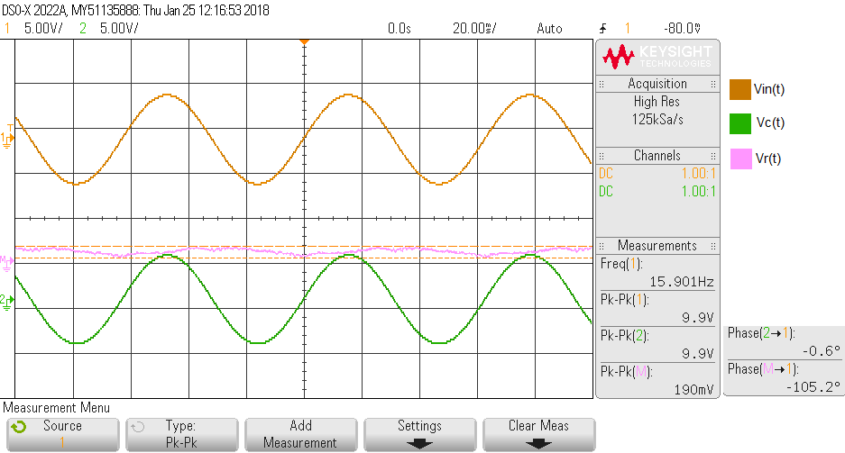

Graph 1: Measurements of Vc(t) and Vr(t) at F = 15.9Hz

Vin(t) = 9.9Vpp, Vin(t) = 4.95 cos (2π15.9t + 0°)V

Vc(t) = 9.9Vpp, θ = -0.6°, Vc(t) = 4.95 cos (2π15.9t - 0.6°)V

Vr(t) = 190mVpp, θ = -105.2°, Vr(t) = 0.095 cos (2π15.9t – 105.2°)V

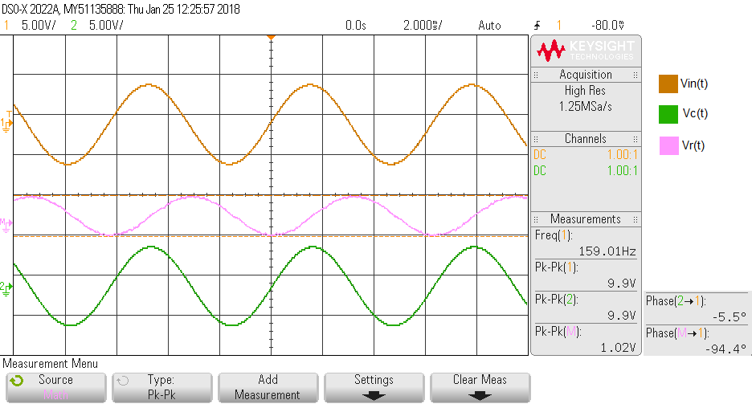

Graph 2: Measurements of Vc(t) and Vr(t) at F = 159Hz

Vin(t) = 9.9Vpp, Vin(t) = 4.95 cos (2π159t + 0°)V

Vc(t) = 9.9Vpp, θ = -5.5°, Vc(t) = 4.95 cos (2π159t – 5.5°)V

Vr(t) = 1.02Vpp, θ = -94.4°, Vr(t) = 0.51 cos (2π159t – 94.4°)V

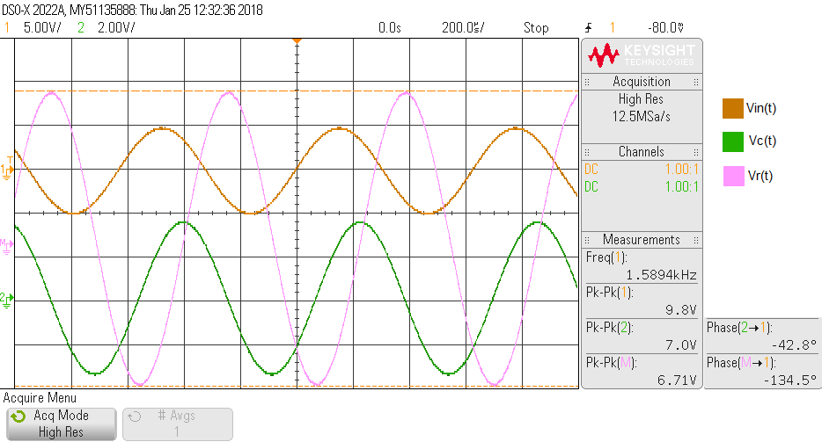

Graph 3: Measurements of Vc(t) and Vr(t) at F = 1590Hz

Vin(t) = 9.8Vpp, Vin(t) = 4.9 cos (2π1590t + 0°)V

Vc(t) = 7.0Vpp, θ = -42.8°, Vc(t) = 3.5 cos (2π1590t – 42.8°)V

Vr(t) = 6.71Vpp, θ = -134.5°, Vr(t) = 3.355 cos (2π1590t – 134.5°)V

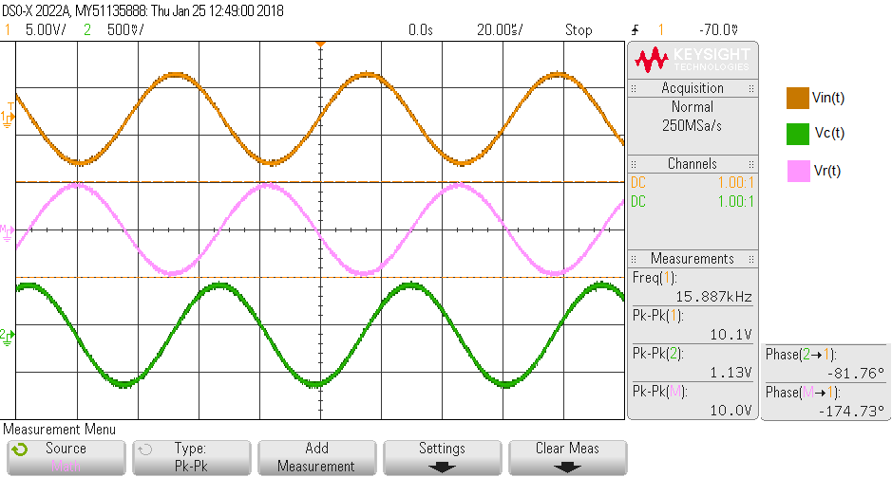

Graph 4: Measurements of Vc(t) and Vr(t) at F = 15.9kHz

Vin(t) = 10.1Vpp, Vin(t) = 5.05 cos (2π15.9kt + 0°)V

Vc(t) = 1.13Vpp, θ = -81.76°, Vc(t) = 0.565 cos (2π15.9kt – 81.76°)V

Vr(t) = 10Vpp, θ = -174.73°, Vr(t) = 5 cos (2π15.9kt – 174.73°)V

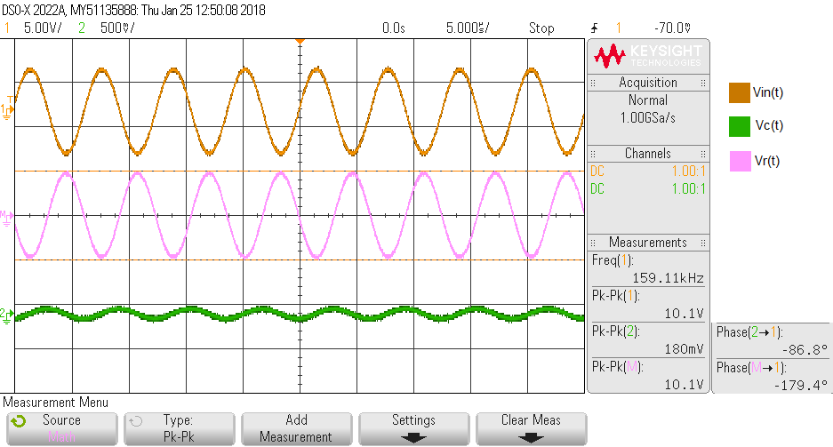

Graph 5: Measurements of Vc(t) and Vr(t) at F = 159kHz

Vin(t) = 10.1Vpp, Vin(t) = 5.05 cos (2π159kt + 0°)V

Vc(t) = 180mVpp, θ = -86.8°, Vc(t) = 0.09 cos (2π159kt – 86.8°)V

Vr(t) = 10.1Vpp, θ = -179.4°, Vr(t) = 5.05 cos (2π159kt – 179.4°)V

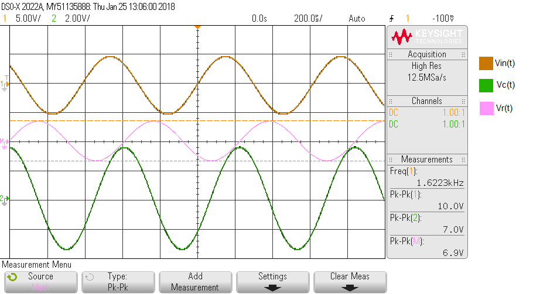

Graph 6: Measurements of Vc(t) and Vr(t) at F = 1623Hz (**Screenshot of Phase missing**)

Vin(t) = 10Vpp, Vin(t) = 5 cos (2π1623t + 0°)V

Vc(t) = 7.0Vpp, θ = -43.0°, Vc(t) = 3.5 cos (2π1623t – 43.0°)V

Vr(t) = 6.9Vpp, θ = -135.4°, Vr(t) = 3.45 cos (2π1623t – 135.4°)V

Finding Frequency of 3dB, where Vc = 3.5Vp:

$$By Nodal Analysis: \frac{V_{c}-V_{in}}{R}+\frac{V_{c}}{Z_{c}}=0$$

$$V_{c}=\frac{5∠0°}{1+jw{10}^{-4}}$$

$$\left|V_{c}\right|=\frac{5}{\sqrt{1^{2}+{\left(w{10}^{-4}\right)}^{2}}}$$

$$w= \frac{\sqrt{{\left(\frac{5}{V_{c}}\right)}^{2}-1}}{{10}^{-4}}=10202.04rad/sec$$

$$Frequency=\frac{w}{2π}=1623.7Hz$$

$$θ=0°-\tan^{-1}\left(\frac{w{10}^{-4}}{1}\right)= -45.57°$$

Table 2

|  |  |  |  |
| --- | --- | --- | --- |
| Vin = | Frequency | Vc(t) | Vr(t) |
| 10Vpp | 15.9Hz | 4.95 cos (2π15.9t - 0.6°)V | 0.095 cos (2π15.9t – 105.2°)V |
| 10Vpp | 159Hz | 4.95 cos (2π159t – 5.5°)V | 0.51 cos (2π159t – 94.4°)V |
| 10Vpp | 1590Hz | 3.5 cos (2π1590t – 42.8°)V | 3.355 cos (2π1590t – 134.5°)V |
| 10Vpp | 15.9kHz | 0.565 cos (2π15.9kt – 81.76°)V | 5 cos (2π15.9kt – 174.73°)V |
| 10Vpp | 159kHz | 0.09 cos (2π159kt – 86.8°)V | 5.05 cos (2π159kt – 179.4°)V |
| 10Vpp | 1623.7Hz | 3.5 cos (2π1623t – 43.0°)V | 3.45 cos (2π1623t – 135.4°)V |

Graph 7: Plot of Vc(t) in logarithmic scale

Graph 8: Plot of Vr(t) in logarithmic scale

**Post Lab**

1. Compare your experimental and calculated results.

Prior to this lab, I have mistakenly written my equation as $$Vc=\frac{5000}{10000+jw}$$

The correct equation is

$$V_{c}= \frac{5}{1+jw{10}^{-4}}$$

The new calculations are much closer to the experimental value.

1. w = 10^2, Vc = 4.99cos((10^2) – 0.57°)V
2. w = 10^3, Vc = 4.5cos((10^3) – 5.7°)V
3. w = 10^4, Vc = 3.5cos((10^4) – 45°)V
4. w = 10^5, Vc = 0.49cos((10^5) – 84.28°)V
5. w = 10^6, Vc = 0.049cos((10^6) – 89°)V
6. Why does the magnitude of the frequency generator change as we vary the frequency?

The frequency changes because the frequency has been varied. Question unclear.

1. Why does the voltage Vc(t) decrease as W increase?

From this equation, $V_{c}= \frac{5}{1+jw{10}^{-4}}$, it is easily seen that as W increase, the denominator increase.

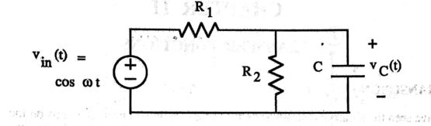

$$let A=Vc, By Nodal Analysis:\frac{A-V}{R_{1}}+\frac{A}{R_{2}}+\frac{A}{\frac{1}{jwc}}=0$$

$$Vc= \frac{R_{2}V}{R_{2}+R_{1}R_{2}+jwcR_{1}R_{2}}$$